The "sequentiality of repeated modular squaring" is the mathematical engine that makes the original 1996 Rivest-Shamir-Wagner (RSW96) Time-Lock Puzzle work. It is a mathematical process designed specifically to resist parallel computing.
Here is exactly how the math works and why it traps the solver in a strict timeline.
1. The Core Equation
To solve the puzzle, a computer must calculate the following equation in an RSA group (where $N$ is a massive number made of two secret primes, $p \times q$):
$$a = g^{2^T} \pmod N$$
- $g$ is a starting number.
- $T$ is the "Time" parameter (a massive number representing how many operations must be done).
2. Why it is "Sequential" (The Solver's Problem)
If you are the solver, you do not know the secret primes $p$ and $q$. Because you do not know the prime factors of $N$, there is no mathematical shortcut to reduce that massive exponent $2^T$.
Your absolutely only option is to compute it the hard way, by taking the starting number and squaring it over and over again, exactly $T$ times:
- Step 1: Calculate $g^2 \pmod N$
- Step 2: Take the answer from Step 1, and square it: $(g^2)^2 = g^4 \pmod N$
- Step 3: Take the answer from Step 2, and square it: $(g^4)^2 = g^8 \pmod N$
... and so on, up to Step $T$.
The Parallel Computing Trap: You cannot calculate Step 3 until you have the exact output of Step 2. Even if you are an attacker with a supercomputer boasting 10,000 CPU cores, 9,999 of those cores will sit completely idle. They cannot help, because the math is strictly linear and sequential. If one squaring takes 1 millisecond, and $T$ is 3.6 million, the puzzle is mathematically guaranteed to take 1 hour to solve, no matter how much hardware is thrown at it.
3. Why it is "Efficient" (The Creator's Trapdoor)
The paragraph you quoted notes that creating the puzzle must be "significantly faster" than solving it.
The person who creates the puzzle does know the secret primes $p$ and $q$. Therefore, they can calculate the Euler Totient of the group: $\phi(N) = (p-1)(q-1)$.
By using Euler's Totient Theorem, the creator can bypass the sequential steps entirely. They reduce the massive exponent first using modulo division:
$$e = 2^T \pmod{\phi(N)}$$
Once they have $e$, they simply compute $g^e \pmod N$. This takes a computer a fraction of a second, whereas the solver is trapped doing millions of sequential squarings to reach the exact same number.

In the standard Rivest-Shamir-Wagner (RSW96) Time-Lock Puzzle, the system is designed so that anyone can be a "solver," meaning almost all the puzzle parameters are completely public.
When the creator locks a message and sends it out into the world, here is exactly what is publicly known (visible to the solver, the server, and any eavesdropper):
The Public Parameters
- $N$ (The RSA Modulus): The massive composite number. The solver needs this because all of the sequential math is done modulo $N$.
- $g$ (The Starting Base): A randomly chosen number that acts as the starting point for the squarings.
- $T$ (The Time Parameter): The exact number of sequential squarings the solver is required to execute.
- $C$ (The Ciphertext): The actual locked message or locked symmetric key. For example, the creator might hide a 256-bit AES key ($K$) by computing $C = K + g^{2^T} \pmod N$.
What must remain STRICTLY PRIVATE
To ensure the puzzle actually takes $T$ time to solve, the creator must absolutely destroy or hide the "trapdoor" information. If any of the following leak, the time-lock is instantly broken:
- $p$ and $q$ (The Prime Factors): The two primes that multiply together to make $N$.
- $\phi(N)$ (The Euler Totient): Which is $(p-1)(q-1)$.
If the solver only has the public variables ($N, g, T, C$), they are locked outside the trapdoor. They know exactly where to start ($g$), how many steps to take ($T$), and what the boundary of the math is ($N$), but because they don't know $p$ and $q$, they are mathematically forced to take the long, sequential road to reach the answer.
The phrase "need not coordinate or even be aware of each other’s participation" highlights the most powerful real-world feature of this specific cryptographic scheme: it is completely decentralized and non-interactive.
To understand why this is a massive breakthrough, consider what "coordination" normally looks like in complex cryptography.
The Problem with "Coordination"
In many multi-party cryptographic protocols (like secure voting or threshold signatures), the participants have to talk to each other before the math can work. They might need to:
- Agree on a shared mathematical seed.
- Assign each other unique index numbers (e.g., "I am user 1, you are user 2").
- Perform a "trusted setup" phase together.
If a Time-Lock Puzzle required this kind of coordination, it would be useless on a public blockchain. Imagine an anonymous sealed-bid auction with 10,000 bidders. It is physically impossible to get 10,000 strangers across the globe to communicate and coordinate a mathematical setup before submitting their bids.
The Meaning of the Last Line
The excerpt is explaining that this specific batching protocol allows for ad-hoc batching.
Alice in Tokyo and Bob in New York can both wake up, generate a Time-Lock Puzzle completely independently, and send them to a server. They do not talk to each other. They do not share keys. They don't even know the other person exists.
Despite this total isolation, the server can still take Alice's puzzle and Bob's puzzle, mathematically multiply them together, and solve them simultaneously in $T$ time.
Summary of the Whole Paragraph
The paragraph is outlining the evolution of Time-Lock Puzzles:
- The Flaw: Standard puzzles are strictly sequential. If a server gets 1,000 puzzles, it takes 1,000 times longer to solve them, causing massive network traffic jams (or allowing attackers to flood the network with junk puzzles).
- The Goal ("Solve one, open many"): We want a server to be able to smash 1,000 puzzles together, do the sequential math exactly once, and unlock all 1,000 answers.
- The Breakthrough ([SLM+23]): We achieved this batching capability without requiring the 1,000 users to coordinate with each other beforehand. It works perfectly for anonymous, decentralized networks.
In computer science and cryptography, a "strawman solution" is a naive, obvious approach that technically solves the problem, but is so inefficient or flawed that it is only introduced so the authors can knock it down and show why their real solution is better.
The authors are saying: "Before we show you our brilliant new math, let's look at the obvious way to batch puzzles and see why it fails in the real world."
Here is the plain-English breakdown of exactly how this naive approach works, the math behind it, and why it ultimately fails.
1. How the Strawman Works: "Bit-Packing"
Imagine $n$ users each have a small secret message of size $\lambda$ bits (e.g., a 256-bit key).
The naive way to combine these messages is to use Homomorphic Bit-Packing.
Look at the equation they provided:
$$f(x_1, \dots, x_n) = \sum_{i=1}^n 2^{(i-1)\cdot \lambda} \cdot x_i$$
In binary mathematics, multiplying a number by $2^k$ is the exact same thing as shifting its bits to the left by $k$ spaces.
- User 1's message ($x_1$) is multiplied by $2^0$ (shifted 0 spaces).
- User 2's message ($x_2$) is multiplied by $2^\lambda$ (shifted left by the size of one message).
- User 3's message ($x_3$) is multiplied by $2^{2\lambda}$ (shifted left by the size of two messages).
If you add them all together, the messages do not overwrite each other. They perfectly line up side-by-side in one giant, long binary number (e.g., [Message 3] [Message 2] [Message 1]).
Because the Time-Lock Puzzle is "linearly homomorphic," the server can do this exact bit-shifting math on the outside of the locked puzzles. The server squishes $n$ locked puzzles together into one giant locked puzzle ($Z^*$). The server solves $Z^*$ by doing the sequential squaring once, unlocks the giant binary number, and simply chops it into $n$ pieces to get the original messages.
2. The Fatal Flaws
This sounds great in theory, but the authors point out two massive mathematical bottlenecks that make it useless for large-scale applications like blockchains:
Limitation A: Bounded Batching (The Maximum Size Limit)
All of this math is being done inside an RSA group, modulo $N$. In modular arithmetic, a number can never be larger than the modulus $N$.
If your RSA modulus $N$ is 2048 bits long, and each message is 256 bits, you can only pack exactly $8$ messages side-by-side before you hit the limit of the RSA group.
If you want to batch 1,000 puzzles, you have to know that limit in advance, and you must generate an impossibly massive RSA modulus (256,000 bits long). Doing cryptography on a 256,000-bit RSA group is so computationally heavy that it defeats the purpose of trying to save time.
Limitation B: Quadratic Overhead ($O(n^2)$)
This is the nail in the coffin for the strawman approach.
In RSA cryptography, the physical file size of a ciphertext is exactly the same size as the modulus $N$.
If the server needs to accommodate $n$ users, the network must use an RSA modulus big enough to hold $n$ messages. Therefore, the file size of a single puzzle becomes $O(n)$.
- When Alice creates her one puzzle, she is forced to send a giant file of size $n$, even though 99% of it is just empty zeroes waiting to be packed.
- When Bob creates his one puzzle, he also sends a giant file of size $n$.
If there are $n$ users on the network, and every single user is uploading a file of size $n$, the total network bandwidth required is $n \times n = O(n^2)$.
The Real World Impact: If you have 10,000 users, the network doesn't handle 10,000 units of data; it has to process 100,000,000 units of data. The communication overhead explodes quadratically, completely crashing the network bandwidth.
The Conclusion: The strawman approach proves that while you can technically combine puzzles by pushing them together side-by-side, it destroys your network bandwidth. The rest of the paper introduces their real solution: mathematically fusing the puzzles together using polynomials so that the file size never grows, entirely avoiding the $O(n^2)$ explosion.
This excerpt contains the absolute mathematical core of the paper. This is the exact algebraic trick you will put on the presentation board to show how the server extracts 1,000 separate messages from a single solved puzzle.
Let’s break this down into three parts: the mathematical tools, the puzzle generation, and the algebraic cancellation that makes it all work.
1. The Two Magical Tools
Before doing the batching, the authors introduce a highly specialized function called a Puncturable Key-Homomorphic PRF. It has two specific algebraic properties:
- Property A: Key-Homomorphic: If you evaluate the PRF with Key A, and evaluate it with Key B, adding the results together is mathematically equivalent to evaluating the PRF using the algebraic sum of the keys.
$$PRF(k_0, i) + PRF(k_1, i) = PRF(k_0 + k_1, i)$$
- Property B: Puncturable: You can generate a "punctured" version of a key ($k^*_i$). This broken key can successfully evaluate the PRF at every single number in the universe, except at the number $i$. If you try to run $PRF(k^*_i, i)$, the math fails and returns nothing.
2. Puzzle Generation (The User's Perspective)
Imagine User $i$ wants to send a secret message ($m_i$). Here is how they lock it up:
- Generate a Key: They randomly generate a standard PRF key ($k_i$).
- Lock the Key (Not the Message): They take that key and lock it inside a standard Time-Lock Puzzle ($Z_i$).
- Mask the Message: They use their key to evaluate the PRF at their own index number $i$. They use the output to mathematically mask their message:
$$c_i = PRF(k_i, i) + m_i$$
- Puncture the Key: They create a punctured version of their key ($k^*_i$), specifically breaking it so it cannot be used at their own index number $i$.
What they send to the server: They upload a package containing four things: (The locked puzzle Z_i, The punctured key k*_i, their index i, the masked message c_i).
Notice the brilliance here: the server has the masked message ($c_i$) and a punctured key. But because the key is punctured specifically at index $i$, the server cannot use it to unmask $c_i$. The message is completely safe.
3. Batch Solving (The Server's Perspective)
The server receives $n$ of these packages from $n$ different users.
- The Homomorphic Sum: The server takes all $n$ of the Time-Lock Puzzles ($Z_1, Z_2, \dots, Z_n$) and adds them together homomorphically. Because they are linearly homomorphic, adding the locked boxes together effectively adds the secret keys inside them.
- The Single Solve: The server spends time $T$ solving this one massive, combined puzzle ($Z^*$).
- The Master Key: When the puzzle opens, the server gets the Master Sum Key ($\tilde{k}$), which is simply the algebraic sum of everyone's individual keys: $\tilde{k} = k_1 + k_2 + \dots + k_n$.
4. The Grand Finale: Algebraic Extraction
This is where the math in your excerpt comes to life. The server now has the Master Sum Key ($\tilde{k}$), and it wants to unlock User $i$'s specific message $m_i$.
The server sets up a cancellation equation. It takes User $i$'s masked message ($c_i$) and adds the PRF evaluations of everyone else's punctured keys, evaluated at index $i$. Then, it subtracts the PRF evaluation of the Master Sum Key.
Let's look at how the algebra collapses:
Step 1: The Setup
$$c_i \quad + \quad \sum_{j \neq i} PRF(k^*_j, i) \quad - \quad PRF(\tilde{k}, i)$$
Step 2: Expand $c_i$ and the Master Key
Substitute $c_i$ with its original definition ($PRF(k_i, i) + m_i$).
Also, by the Key-Homomorphic property, $PRF(\tilde{k}, i)$ expands out to the sum of all individual PRF evaluations.
$$[PRF(k_i, i) + m_i] \quad + \quad \sum_{j \neq i} PRF(k^*_j, i) \quad - \quad \sum_{all} PRF(k_x, i)$$
Step 3: The Punctured Key Trick
Because we are evaluating at index $i$, everyone else's punctured keys work perfectly! For everyone else, $PRF(k^*_j, i) = PRF(k_j, i)$.
$$[PRF(k_i, i) + m_i] \quad + \quad \sum_{j \neq i} PRF(k_j, i) \quad - \quad \sum_{all} PRF(k_x, i)$$
Step 4: The Final Cancellation
Look at the terms. If you take User $i$'s PRF evaluation, and add everyone else's PRF evaluations, you literally just get the PRF evaluations of everyone.
$$[ \text{Everyone's PRFs} ] + m_i \quad - \quad [ \text{Everyone's PRFs} ]$$
The PRF terms completely cancel each other out to zero, leaving the server holding exactly one thing:
$$= m_i$$
Why this is a massive leap forward
The last sentence of the excerpt compares this elegant algebra to the previous best paper ([SLM+23]). The previous paper required users to send "obfuscated circuits" (giant, theoretical, compiled computer programs) across the network to handle the batching.
By replacing complex computer programs with pure algebraic cancellation over a Key-Homomorphic PRF, the authors made the protocol exponentially smaller, faster, and infinitely easier to prove securely.
This excerpt explains the brilliant mathematical trick the authors use to solve a massive real-world problem: How do we guarantee every user gets a unique identifier without them talking to each other?
If two users accidentally pick the exact same index number, their PRF math will collide, and the server will not be able to separate their messages when the puzzle opens.
Here is the plain-English breakdown of how they solve this using graph theory and the Birthday Paradox.
1. The "Unbounded" Setting (Easy Mode)
If the mathematical engine (the PRF) can handle an infinitely large universe of numbers—say, $2^{256}$ possible indices—the solution is trivial. Every user just rolls a giant cryptographic dice and picks a random 256-bit number.
Because the universe of numbers is so massive, the probability of two users randomly picking the exact same number is practically zero (this is basic Birthday Paradox math).
2. The "Bounded" Setting (The Hard Problem)
Some of their PRF constructions (like the polynomial lattice ones) can only handle a small, strictly bounded universe of numbers. Imagine the server can only support $n = 1,000$ indices.
If 1,000 users all randomly pick a number between 1 and 1,000 without talking to each other, you are mathematically guaranteed to have massive collisions. Multiple users will pick the number "7", their math will crash into each other, and the batching protocol will fail.
3. The Graph Theory Solution (Bipartite Matching)
The authors reframe this probability problem as a Bipartite Graph problem.
- Let set $U$ be the Users.
- Let set $V$ be the available Index Numbers.
Instead of a user picking just one index and crossing their fingers, the protocol forces every user to pick a small handful of random indices (let's call that number $d$).
For example, Alice claims indices {4, 19, 87}. Bob claims {19, 42, 105}. Charlie claims {4, 99, 105}.
When the server receives everyone's puzzles, it looks at all the requested indices. The server runs a matching algorithm to draw lines between the Users ($U$) and the Indices ($V$) so that every single user gets exactly one unique index, with no overlaps. This is called finding a Perfect Matching.
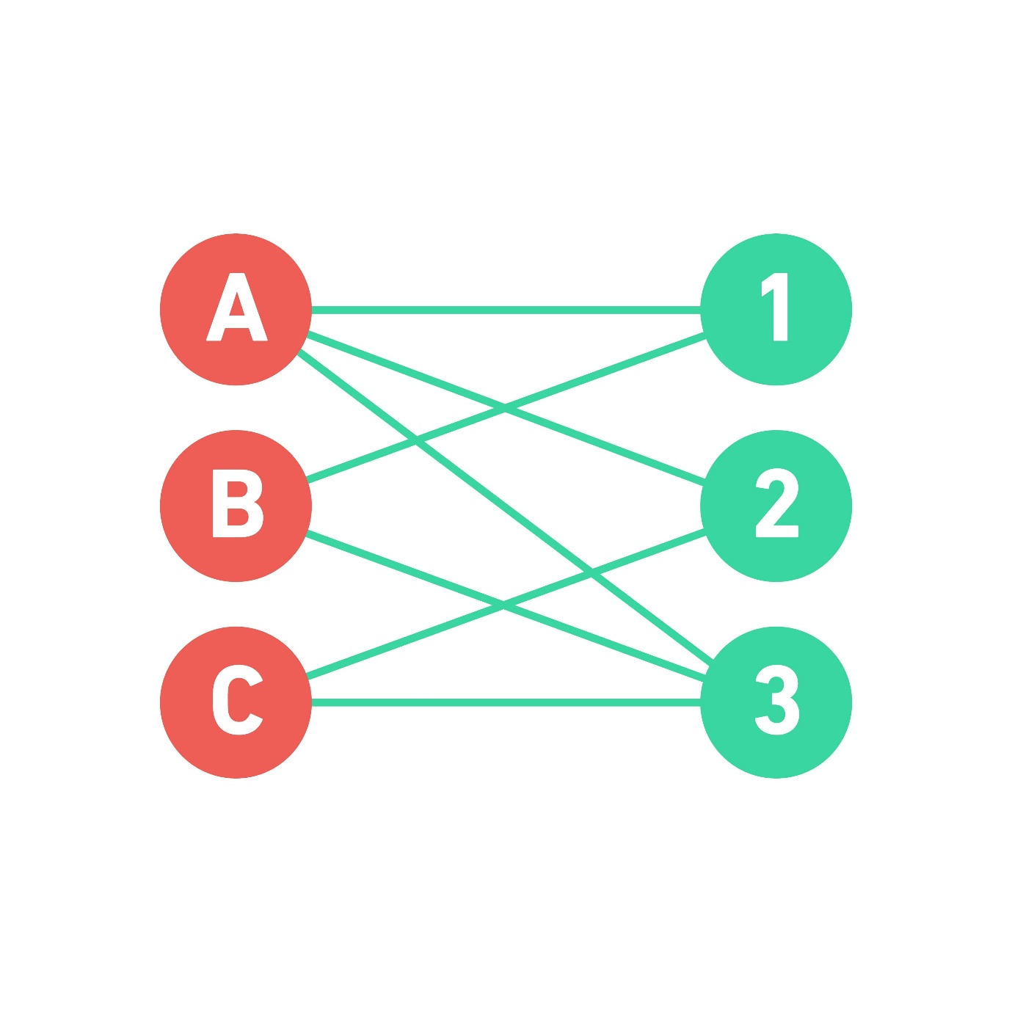
Shutterstock
Explore
4. The Math: Hall's Marriage Theorem
This is the theoretical climax of this section. The server can only find a Perfect Matching if the mathematical conditions actually allow for it. What if Alice, Bob, and Charlie all only picked {4, 19}? The server couldn't match them uniquely, because 3 people are fighting over 2 spots.
The authors use Hall's Marriage Theorem, a famous theorem in combinatorics.
The theorem states: A perfect matching exists if and only if for every subset of users ($X$), the total number of unique indices they selected ($\Gamma(X)$) is greater than or equal to the number of users in that subset ($|\Gamma(X)| \ge |X|$).
The Optimization:
The authors applied this theorem to figure out exactly how many choices ($d$) a user needs to make, and how big the index pool ($n_{new}$) needs to be to mathematically guarantee a perfect matching exists.
- If $d$ is too large, the puzzle file sizes get too big.
- If the index pool $n_{new}$ is too large, the public parameters get too heavy.
Using Hall's Marriage Theorem, they mathematically proved the perfect "Goldilocks" zone:
If you make the index pool just 3 times larger than the number of users ($n_{new} \ge 3 \cdot n$), and you have each user pick $d = \lambda / \log(n_{new})$ random choices, the server will almost certainly find a perfect matching every single time, without the users ever having to coordinate!
This section is pure, unadulterated group theory, and it is going to be the absolute star of your presentation. It explains the exact algebraic machinery of how to build a Puncturable Key-Homomorphic PRF using Bilinear Pairings on Elliptic Curves.
Here is the complete, plain-English breakdown of the math, starting with the $H()$ function you asked about.
1. The "H() Thingy" (The Naive Approach)
The authors start by looking at an older, simpler PRF to show why it doesn't quite work.
The $H(i)$ is a Cryptographic Hash Function acting as a "Random Oracle". In group theory, this means the hash function takes a normal number (like the user index $i$) and hashes it into a random point on a cyclic group (like an elliptic curve).
If the PRF is defined as $PRF(k, i) = H(i)^k$, it has perfect key-homomorphism:
$$H(i)^{k_0} \cdot H(i)^{k_1} = H(i)^{k_0 + k_1}$$
The Problem: You cannot "puncture" this. If you give someone the secret key $k$, they can compute $H(i)^k$ for every index. If you don't give them $k$, they can't compute it for any index. There is no mathematical way to give them a key that works for 99 indices but fails on the 100th.
2. The Bilinear Pairing Solution
To fix this, the authors move to Bilinear Pairings.
A bilinear pairing is a magical mathematical map $e(A, B)$ that takes two points on an elliptic curve and maps them to a target group, allowing you to multiply their hidden exponents:
$$e(g^a, g^b) = e(g,g)^{a \cdot b}$$
3. The Setup (The Public Parameters)
Because they are working in a "bounded" domain (where the maximum number of users $n$ is known in advance), a central authority can pre-compute a massive grid of public parameters.
They randomly pick two sets of secret numbers: $x_1 \dots x_n$ and $z_1 \dots z_n$.
They publish two things to the world:
- $g^{x_i}$ for every user.
- The cross-terms: $g^{z_i / x_j}$ for every combination where $j \neq i$.
Notice the crucial detail: They publish every cross-term except the diagonal where $j = i$. The term $g^{z_1 / x_1}$ does not exist in the public record.
4. The Punctured Key Trick (The Genius Step)
The goal is to give a user (let's call them User $i^*$) a key that lets them evaluate the PRF at any index $i$, except their own index $i^*$.
The true Master Key is just a random number $k$.
Instead of giving User $i^*$ the Master Key $k$, the system gives them a Punctured Key:
$$k^*_{i^*} = g^{x_{i^*} \cdot k}$$
How the user evaluates a valid point ($i \neq i^*$):
The user wants to evaluate the PRF for someone else's index $i$. They take their punctured key and mathematically pair it with the public cross-term $g^{z_i / x_{i^*}}$ from the setup phase:
$$e\left( g^{x_{i^*} \cdot k}, g^{z_i / x_{i^*}} \right)$$
Using the rules of bilinear pairings, the exponents multiply together:
$$= e(g,g)^{(x_{i^*} \cdot k) \cdot (z_i / x_{i^*})}$$
Look at the beautiful algebraic cancellation! The $x_{i^*}$ in the numerator and denominator completely cancel each other out, leaving:
$$= e(g,g)^{z_i \cdot k}$$
They successfully evaluated the PRF!
Why they CANNOT evaluate their own point ($i = i^*$):
What happens if User $i^*$ tries to use their punctured key to evaluate their own index?
They would need to pair their key $g^{x_{i^*} \cdot k}$ with the public parameter $g^{z_{i^*} / x_{i^*}}$.
But remember Step 3! That specific public parameter was intentionally deleted from the setup. It does not exist. The user is mathematically stranded and cannot compute the PRF for their own index. The key is perfectly punctured.
5. The Quadratic Drawback
The paragraph ends by noting an efficiency limitation. Because the setup requires publishing $g^{z_i / x_j}$ for every possible combination of $i$ and $j$, the total number of public parameters is $n \times n$.
If you have 10,000 users, the setup phase has to publish 100 million group elements. This $O(n^2)$ size is called "quadratic overhead," and it makes the public parameters very heavy to download.
(The authors immediately solve this quadratic problem in the next section using a $q$-type assumption to shrink the parameters down to $O(n)$ linear size, but this specific excerpt is just establishing the baseline $O(n^2)$ math).
Presentation Advice
This specific algebraic cancellation—where $x_{i^*}$ is multiplied by $z_i / x_{i^*}$ inside the bilinear pairing—is the exact mathematical proof you should put on your slides. It is clean, it relies purely on the discrete logarithm and elliptic curve group theory you excel at, and it perfectly explains how a mathematical "trapdoor" can be built into a key without destroying its homomorphic properties!
WHY is the above method considered a PRF???
Answer :
You are partially correct, but there is a second, crucial layer to it.
The random choice of $z_j$ during the setup is what makes the public parameters secure, but the actual pseudorandomness (what makes it a PRF) relies on the secret Master Key $k$ and a famous cryptographic rule called the Decisional Bilinear Diffie-Hellman (DBDH) Assumption.
Here is the exact breakdown of why that specific output behaves like a PRF.
1. The Definition of a PRF
For a function to be a PRF, its output must look completely, mathematically indistinguishable from a random coin toss to anyone who does not have the correct key.
The output of the function is: $e(g,g)^{z_{i} \cdot k}$.
- If you know $k$, it is a deterministic function. You can calculate it perfectly.
- If you do not know $k$, it must look completely random.
2. The Attacker's Perspective (The Punctured Point)
To prove this is a secure Puncturable PRF, we have to look at the attacker.
The attacker is given the Punctured Key for index $i^*$:
$$k^*_{i^*} = g^{x_{i^*} \cdot k}$$
The attacker's goal is to guess the PRF output at that punctured point:
$$\text{Target} = e(g,g)^{z_{i^*} \cdot k}$$
To get there, the attacker needs to pair their punctured key with something. But as we established earlier, the central authority intentionally deleted $g^{z_{i^*} / x_{i^*}}$ from the public board.
3. The Cryptographic Hardness (Why it is a PRF)
This is where the true PRF nature kicks in.
The attacker has a bunch of public points ($g^{x_j}$ and $g^{z_i/x_j}$) and their punctured key ($g^{x_{i^*} \cdot k}$).
Can the attacker use advanced algebra to somehow combine, multiply, or pair the other public points together to artificially forge the target value $e(g,g)^{z_{i^*} \cdot k}$?
No. This is the underlying cryptographic assumption. In bilinear pairing cryptography (specifically under $q$-type assumptions or DBDH), it is mathematically proven that if you are missing that one specific matching piece in the exponent, generating the target pairing output is as hard as solving the Discrete Logarithm problem.
Summary
The output behaves like a PRF not just because $z_j$ is random, but because:
- $k$ is a random secret, meaning the final exponent $z_{i^*} \cdot k$ is entirely unpredictable.
- The Bilinear Hardness Assumption guarantees that an attacker cannot use other public parameters to "cheat" and calculate the pairing.
Because the attacker physically cannot compute the answer, the value $e(g,g)^{z_{i^*} \cdot k}$ is computationally indistinguishable from a truly random point in the target group. Therefore, it perfectly satisfies the definition of a Pseudorandom Function!
This section is the "Defense" chapter of the paper. Up until now, the math assumed everyone playing the game was honest. But in a decentralized network, an attacker will intentionally submit mathematically "poisoned" puzzles to ruin the batch for the honest users.
This is called a Rogue-Puzzle Attack. If the server adds 999 honest puzzles and 1 poisoned puzzle together homomorphically, the result is garbage, and nobody gets their messages.
Here is the complete breakdown of the two ways an attacker can poison the batch, and how the authors mathematically stop them.
Attack 1: Malformed Homomorphic Puzzles
An attacker could submit a puzzle that is just random mathematical noise instead of a properly formatted key. When the server homomorphically multiplies this noise into the batch, it destroys the underlying group structure.
The Fix: Non-Interactive Zero-Knowledge Proofs (NIZKs)
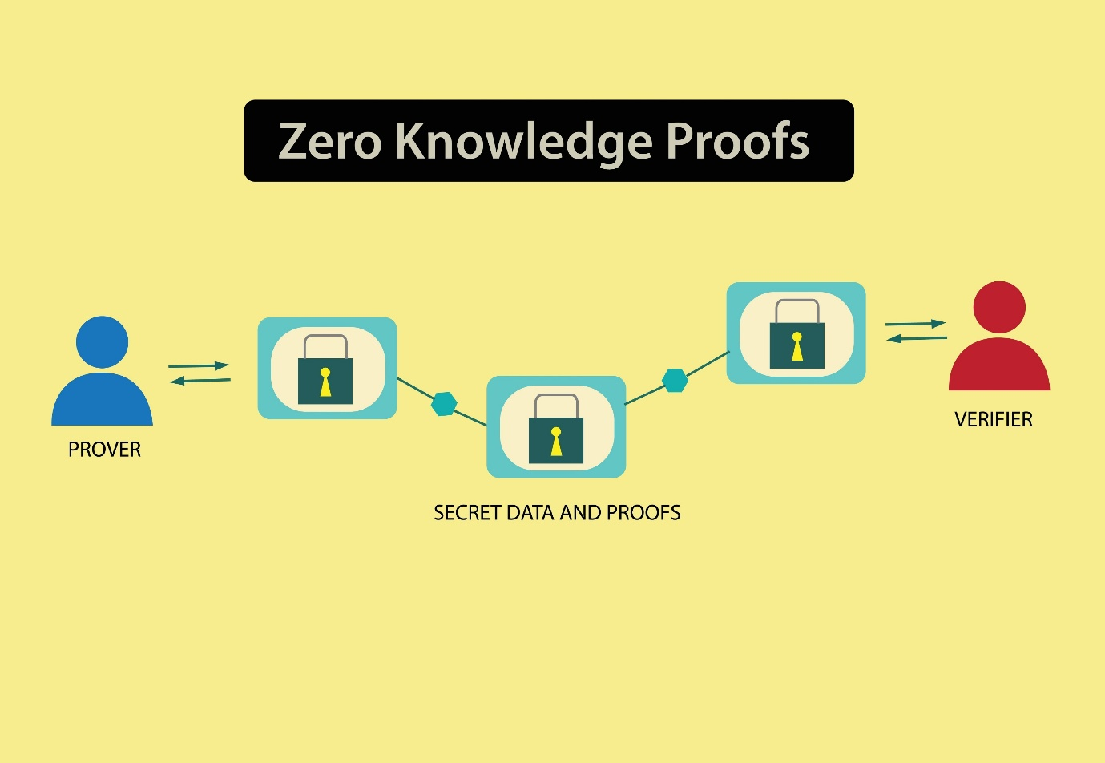
Shutterstock
Explore
The server forces every user to attach a mathematical proof to their puzzle. The IsValid algorithm checks this proof before allowing the puzzle into the batch.
For the pairing-based construction, the authors use a variant of the Schnorr / Chaum-Pedersen Protocol.
Because the puzzle hides a Master Key $k$, the user must prove: "I know the discrete logarithm exponent $k$ used to create this puzzle, and it is formatted correctly," without ever revealing $k$. The server checks the Chaum-Pedersen equations. If the math doesn't align, the server instantly drops the puzzle.
Attack 2: The "Collision of Indices" (The Hash Idea)
This is where your specific question comes in.
Remember that the batching protocol only works if every user gets a unique index. An attacker might say: "I know Alice is using index 42. I am going to intentionally submit a puzzle asking for index 42 to force a collision and break her math."
Clarifying the Hash Idea:
They do not hash the index to get a new index.
Instead, they mathematically force the user's index to be derived from the puzzle itself:
$$\text{Index} = \text{Hash}(\text{Locked Puzzle Data})$$
If an attacker wants to target index 42, they cannot just "pick" 42. They have to generate a valid Time-Lock Puzzle, hash it, and hope the output is 42. If it outputs 87, they have to throw the puzzle away, generate a completely new puzzle with new keys, and try again.
Because creating a valid puzzle (and generating the Chaum-Pedersen ZKP for it) takes computational effort, forcing the attacker to "grind" through millions of puzzle generations just to target a specific index becomes computationally impossible.
The "Bounded Problem" (Why Hashing Usually Fails Here)
This is the most subtle mathematical detail in the excerpt.
Normally, cryptographic hashes (like SHA-256) output a massive, 256-bit number. Finding a collision in a space of $2^{256}$ is practically impossible.
However, in the "bounded" version of this protocol, the server might only support $n = 1,000$ users. That means the hash function must output a number between 1 and 1,000 (a "polynomial size" domain).
The Attacker's Advantage: If the target space is only 1 to 1,000, finding a collision is incredibly easy! The attacker only has to generate roughly 1,000 puzzles before the hash function accidentally spits out Alice's index of 42. This completely breaks the security.
The Rescue: Bipartite Matching to the Rescue
The authors realized they had a massive problem. The hash space is too small, making collisions too easy to find.
How do they save the protocol? They look back at the Bipartite Matching / Hall's Marriage Theorem trick they used earlier.
Because every user doesn't just get one index, but rather a small set of random indices (e.g., $d$ choices), the attacker's job becomes exponentially harder.
To actually break the server's batching, the attacker cannot just cause one collision. They have to mathematically flood the bipartite graph with enough maliciously crafted index choices to completely prevent the server from finding a perfect matching for the honest users.
By analyzing the graph theory in the Random Oracle Model (ROM), the authors proved that even with a tiny hash space, the bipartite matching algorithm naturally absorbs the attacker's collisions. The attacker would have to spend an impossible amount of computing power generating puzzles to trap the matching algorithm into a dead end.

The proof for Theorem 3.3 mathematically verifies that the server will always extract the exact, correct messages for every user after batching them together, without the data becoming corrupted by the homomorphic addition or the PRF noise.
The proof is broken down into four distinct mathematical phases.
Phase 1: Preventing Overflow (The Modulus Bounds)
When the server homomorphically adds $n$ Time-Lock Puzzles together, it is performing addition inside an RSA group modulo $N$. If the numbers get too large and exceed $N$, they "wrap around" (modulo arithmetic) and the data is permanently destroyed.
The proof begins by verifying the Encode bounds. It shows that even if you take the maximum possible value of a PRF key, and multiply it by the total number of users ($n$), the result is $n \cdot p^{2\ell}$. Because the system was strictly configured so that $n \cdot p^{2\ell} < N$, a mathematical overflow is impossible. The homomorphic addition behaves exactly like normal, safe integer addition.
Phase 2: Decoding the Master Key
Because the homomorphic addition happened without any modulus wrap-around, the Decode algorithm works perfectly.
When the server opens the batched puzzle, it gets $\tilde{k}$. The decoding process unpacks this giant integer back into a vector of base-$p$ numbers.
The proof establishes that this decoded Master Key ($k'$) is exactly equal to the algebraic sum of all the individual users' keys:
$$k' = \sum_{j \in S} k_j$$
Phase 3: The Algebraic Cancellation
Now the server runs the extraction equation for a specific user, $i$. It takes that user's masked message ($c_i$), adds the PRF evaluations of everyone else's punctured keys, and subtracts the PRF evaluation of the Master Key.
$$\mu_i = c_i + \sum_{j \neq i} PRF(k^*_j, i) - PRF(k', i)$$
Substitute $k'$ with the sum of all keys we proved in Phase 2:
$$\mu_i = c_i + \sum_{j \neq i} PRF(k^*_j, i) - PRF\left(\sum_{all} k_j, i\right)$$
This is where the properties of the PRF activate:
- Key-Homomorphism: Evaluating the sum of keys is mathematically equivalent to the sum of the individual evaluations, plus a tiny mathematical noise/error term ($e$).
- Punctured Correctness: The punctured keys evaluate exactly like normal keys, plus another tiny error term ($e'$).
Applying these properties, the equation expands to:
$$\mu_i = c_i + \sum_{j \neq i} PRF(k_j, i) - \sum_{all} PRF(k_j, i) + e + e'$$
If you take the sum of everyone's PRFs, and subtract the sum of everyone except $i$, the only thing left is user $i$'s PRF. The equation collapses beautifully to:
$$\mu_i = c_i - PRF(k_i, i) + e + e'$$
Phase 4: Unmasking and Rounding
Recall from the Gen algorithm how the user originally created $c_i$. They took their secret message ($m_i$), multiplied it by a massive scaling factor ($\lceil p/2 \rceil$), and masked it with their PRF:
$$c_i = PRF(k_i, i) + m_i \cdot \lceil p/2 \rceil$$
Substitute this exact definition of $c_i$ back into our collapsed equation from Phase 3:
$$\mu_i = \left[ PRF(k_i, i) + m_i \cdot \lceil p/2 \rceil \right] - PRF(k_i, i) + e + e'$$
The PRF mask completely cancels itself out to zero, leaving:
$$\mu_i = m_i \cdot \lceil p/2 \rceil + e + e'$$
The Final Step: The server has the message, but it is covered in mathematical noise ($e + e'$). However, the proof relies on the fact that the message was intentionally scaled up by a massive number ($p/2$). The noise terms are mathematically bounded to be very small (at most $4n$). Because the true message is so mathematically "loud" and the noise is so "quiet," simply rounding the number completely erases the noise, leaving the server with the exact, pristine message $m_i$.

